Vi Editor - Assignments
- Invoke the vi editor with a filename (which is to be created) : vi sample
- Type a few lines(at least 10) in the editor. Let one or more lines contain the words given below.
delhi mumbai chennai Mumbai 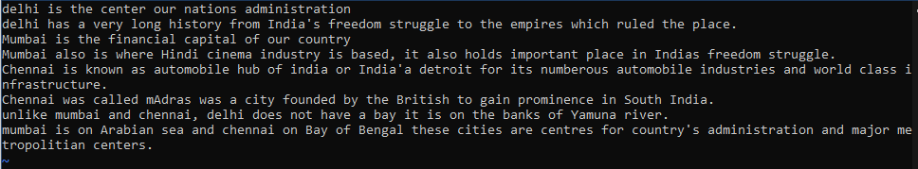
- Save the file without exiting the editor: :w
- Navigate quickly to the beginning & end of the file: gg & G
- Delete first two lines & copy it after the last line.: 2dd - delete first two, G-go to last line, $-to go to end of last line , p-paste after the cursor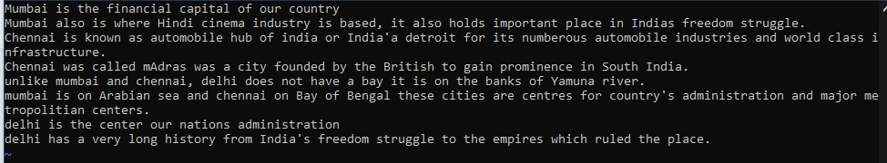
- Now Copy the last two lines & paste them before the first line. yy-to copy last two lines from the cursor, g-go to first line, P-paste it before cursor 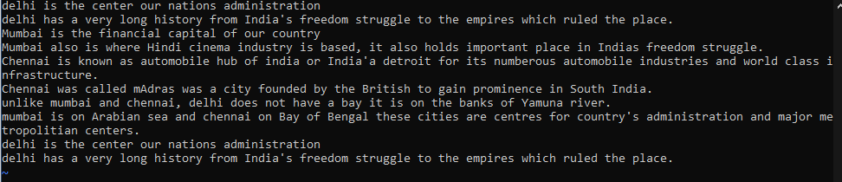
- Combine last two lines of the file in a single line. J
- How will you insert a line before the first line? (Hint : Find such an option in the tutorial document): i
- How will you paste a yanked buffer before the current line? :P
- Search the document for a string “delhi”:/delhi
- Replace a single occurrence of “delhi” with “Mumbai”::s/delhi/Mumbai
- Replace all occurrences of “delhi” on a particular line with “Mumbai” using one command:s/delhi/Mumbai/8: 8th line ,
- Replace “delhi” with “mumbai” for the entire document using one command.: :%s/delhi/Mumbai/g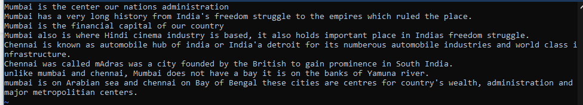
- Replace all occurrences of “delhi” with “mumbai” for part of a document (e.g. line number 13 to 37). considering 2-8 lines :2,8s/delhi/Mumbai/g 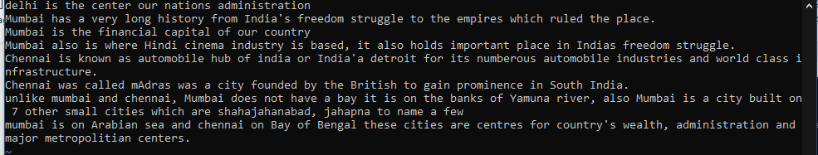
- Undo the above command: u

- Replace only the first occurrence of “delhi” with “mumbai” in each line, for part of a document (e.g. line number 13 to 37).: :2,8s/delhi/Mumbai 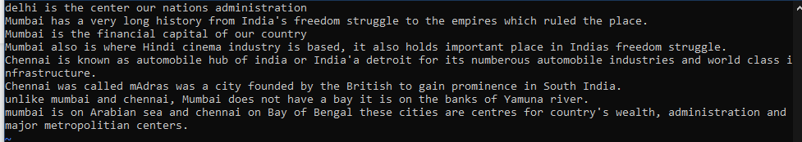
- Undo the above comment. Redo it. Undo it again.: u ctrl+R u
- Replace all occurrences of “delhi” with “mumbai” for complete file interactively.:%s/delhi/Mumbai/gc and a
- Search for a word backwards. Loop through all matches./delhi
- Search for a word forwards. Loop through all matches: ?delhi
- Join two lines together.:J
- Enable line numbering and then disable i:set number and set nonumber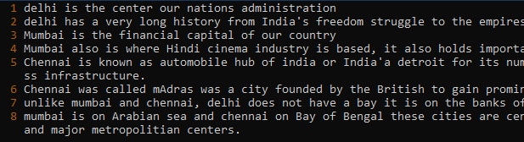
- Make the search case insensitive:set noic
- Delete 4 lines (and then paste them somewhere else): 4dd and P
- What is the command to delete part of the line starting from the current cursor position?D
- What is the command to delete the current word?dw

